District Lead Volunteer Search
Cotswold District is searching for a new District Lead Volunteer, or District Lead Volunteer Team.
Scouting relies on volunteers and Cotswold District is seeking a volunteer manager or a team of volunteer managers, with energy and enthusiasm to lead them in the role of District Lead Volunteer or District Lead Volunteer Team.
The District Lead Volunteer or District Lead Volunteer Team will be the area managers who lead the District Team(s) along with the District Youth Lead(s) in supporting the local Scout Groups so that the young people get the best quality scouting they can. We recognise that this role will suit either an individual or a role share with a team of 2 or 3 people.
We are looking for volunteer adults who want to make a difference in their local communities, someone who has enthusiasm and enjoys working with other adults and young people. Could this be you or do you know someone who has the ability to motivate others? Do you know someone who you think would make a great DLV or work well as part of a Team? There is no requirement to be a current member of Scouting.
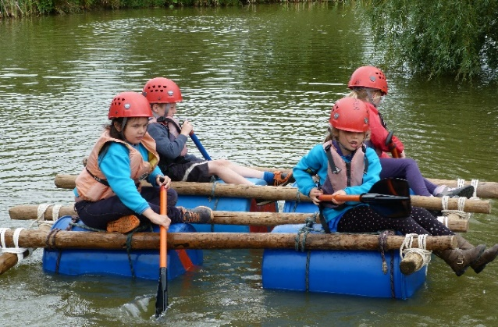
What’s in it for you?
You will know that you are making a difference to the young people and the adults within the District. Scouting is flexible and this role is open to role share within a small team. The DLV or DLV Team will be working with an existing team of adults including our District Youth Lead to ensure every young person and adult has what they need to be confident in what they do. You will have access to training relevant to the role and will have an induction to ensure you get the very best start in the role. The skills that you will use as a District Lead Volunteer, such as Leadership, can enhance your CV and can be a great way to demonstrate to prospective employers that you have additional skills.
Why is this so important to Cotswold Scout District?
We believe that Scouting in this District has some amazing people. Ordinary people who together make extraordinary things happen giving our young people the skills for life. Helping these leaders and young people to do their best takes support and guidance from an inspiring team.
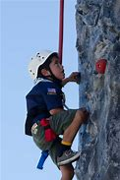
What are we looking for?
We are eager to speak with individuals who would like to explore joining us and can offer the following skills sets:

Leadership and Management
The ability to share skills and knowledge
Having a focus on fun
To motivate and bring the best out of people
Being able to bring people together
Working with young people as well as adults
Helping our young adults to grow to become our leaders of the future.

For an initial and informal discussion please contact: either Dave Hall at dave.hall@gloucestershire-scouts.org.uk or Carole O’Donnell on 07999948263

Or complete the Expression of Interest Form and return to admin@gloucestershire-scouts.org.uk

Expression of Interest Form – Cotswold District Lead Volunteer or DLV Team

If you are interested in applying for one of these roles, please complete the expression of interest form below.
DATA PROTECTION: This form is used to collect information and personal data about you for the purpose of shortlisting potential candidates and in the decision-making process for the appointment of a DLV or DLV team for Cotswold District. This data will be used by the members of the District search team, the selection panel and the County Appointment Advisory Committee. We do not share your personal data provided in this form with any third parties. We take your personal data privacy seriously. We will keep the data we capture from this form only as long as necessary and it will be securely disposed of once appointments to the roles have been made.

Name

Telephone Number

Email address

Please state whether you wish to be part of a DLV team or and individual DLV.

Please outline why you are expressing an interest in this role.

What skills and talents do you feel you can bring to the role?

SHORT PROFILE FOR COTSWOLD DISTRICT

COTSWOLD
Cotswold District Scouts
Part of Gloucestershire County Scouting which is made up of 9 Scouting Districts. Based in a lovely part of the Cotswolds are the 6 groups that make up the District Covering Cirencester to Lechlade area the total membership is currently 209 members supported by 86 adults made up of:

63 Beaver Scouts (6 – 8 year olds)
86 Cub Scouts (8 – 10 ½ year olds)
62 Scouts (10 ½ - 14 year olds)
6 Explorer Scouts (14 – 18 year olds)
4 Network member
82 Adult volunteers

Cotswold Scout Groups

- 1st Cirencester
- 1st Fairford
- 1st South Cerney
- 2nd Cirencester (Stratton)
- Deer Park (Kemble)
- 1 x Explorer Unit

