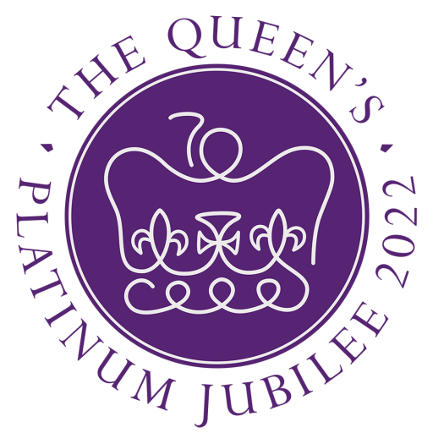

Activity Passport

Name ________________________________

Queen's Jubilee

Celebration Badge
Gloucestershire Scouts celebrates the Queen’s Platinum Jubilee

In recognition of this milestones which takes place this year, we have launched a Gloucestershire Scouts Jubilee badge which is open to all young people aged 4 – 25 and all adults too!

Throughout the coming months we want to give every young people the opportunity and encouragement to learn more about The Queen, many of the initiatives surrounding this event.

It all starts with a Badge Design Competition where one lucky winner will have their badge turned into a woven occasional badge which will be approved for wear on everyone’s uniform.

To achieve the badge award a person needs to complete a minimum of 15 challenges from the list below in order to be awarded the badge. When you have completed your 15 challenges, let your leader know so that they can see your great work and order you a badge.
For details of the activities see
https://gscouts.org.uk/queens-jubilee

Activity Number | Brief Description of Activity | Leader Sign off when completed

41st Gloucester
Scout Group

