Beaver Evening links

Lego beaver dams

https://littlebinsforlittlehands.com/lego-water-activity-building-dams-stem/

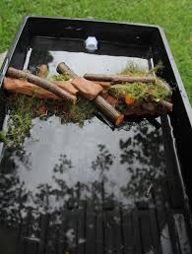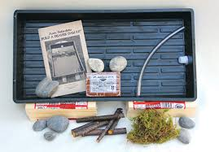

David Attenborough video (approx. 10mins) on Beavers in USA
https://youtu.be/iyNA62FrKCE

