Morse Code Challenge
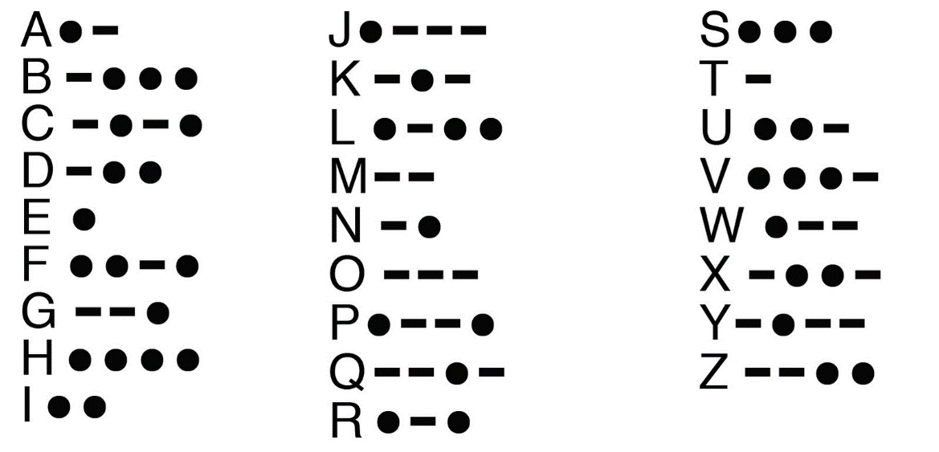
Morse code is a way to send messages without using words. The code has its own alphabet of long and short sounds or flashes of light. Use the Morse Code to translate the message below.

Can you spell your name in Morse Code?_______________ ____________________________________________

